**Beyond the Classroom**

Chanel Schear

ECC

07/01/2024

**Beyond the Classroom**

**Activity One: Volunteer Work at a Senior Nursing Center**

While learning and working as a nursing student, I had the opportunity to work at a senior nursing center. I had made the realization that I have a strong interest in caring for senior people compared to the fast-paced nature of the acute care environment. I chose the care of aged patients because they grant experience in dealing with complex health challenges. I chose to volunteer because I perceived such experiences to be critical in the understanding of daily realities that are beyond the classroom.

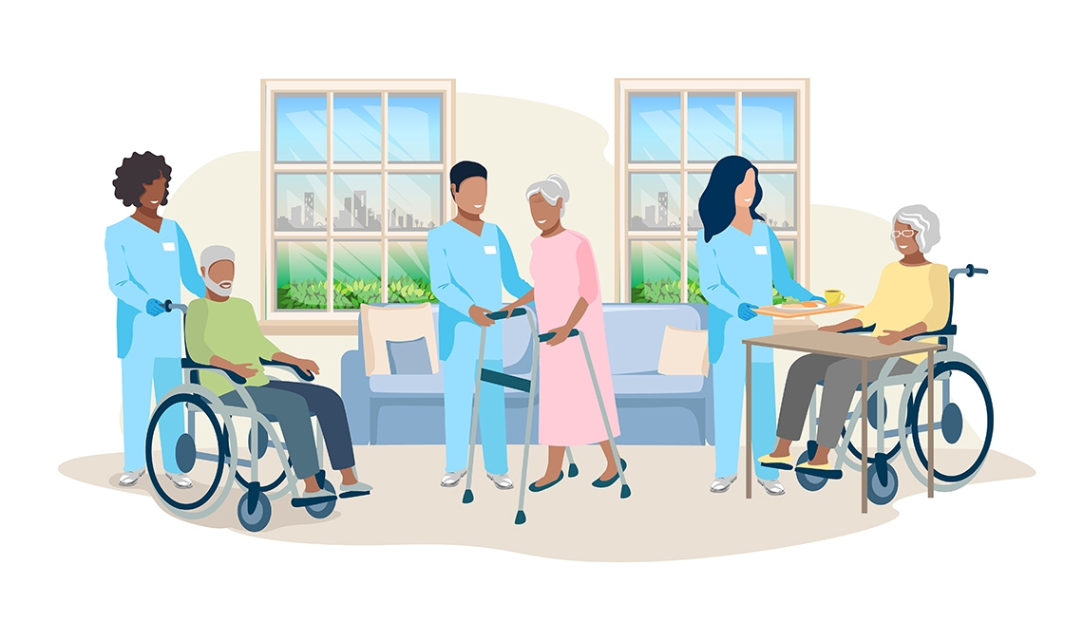

Fig 1: Providing companionship to senior patients

**What I Did.**

Most of the work I did at the senior nursing center revolved around the provision of companionship to the patients. The role entailed assisting the patients with daily activities, such as feeding, reading books aloud in a group setting, and playing games among many others. The job also centered on planning and taking part in organized social events and outings for the patients. The objective of the role was to lessen the perception among the patients that they were receiving senior care. I chose this activity because it was immensely rewarding as a professional experience for a nursing student.

**Relevance of the Activity**

Working at the senior nursing center played an essential role in me developing empathy and patience as professional attributes. The role was equally important in how it enabled me to build constructive relationships with patients and colleagues, which solidified my passion for working in the healthcare setting. Empathy and patients will prove invaluable in my future provision of care. The job opened up my eyes to the importance of social connections in the emotional wellbeing of senior patients. While the job did not directly relate to medical coding, which is my next career path, the interpersonal and communication skills acquired will prove valuable in this endeavor.

**Activity Two: Internship in Medical Coding**



Following the decision to acquire an associate degree and pursue a career in medical coding, I was fortunate enough to secure an short internship position at a local health facility’s billing department. The job not only centered on the financial aspects of healthcare but also the analytical ones as revenue generation was a significant indicator of organizational performance. I shadowed a seasoned professional coder throughout my time in the internship program. I chose the position because it is integrated into various healthcare processes and departments, meaning it enhanced my understanding of various components of the healthcare system.

**What I Did**

My job centered mostly on observing and replicating the daily tasks of the supervising medical coder. A typical day would include a review of medical records, the assigning of codes to specific medicines and treatment regimens, and ensuring the accurate disbursement of medical services. There was also the translating of medical diagnosis, procedures, and treatments into universal codes and texts. As a result of working in such a department, I was able to understand and navigate complex coding systems and databases, attaining proficiency in universal coding classifications, such as Current Procedural Terminology (CPT).

**Relevance of the Activity**

Beyond the technical skills involved in medical coding, the internship widened my appreciation for healthcare operations and management. I acquired knowledge on the financial elements of healthcare delivery, including the processing of insurance claims. The critical and analytical thinking associated with the position was instrumental in relating class lessons on healthcare administration with real-world applications. In addition, the position reinforced the importance of paying attention to detail in healthcare coding and documentation. Accuracy is critical to maintaining high levels of care quality. Coding for different healthcare departments and processes also exposed me to the multidisciplinary and collaborative aspects of contemporary patient care.